Weather APP Assignment REPORT

Contents

Introduction 1

Web Page 1

Ajax 3

DOM 3

CSS 4

CONCLUSION 5

# **Introduction**

The goal to create this assignment is to connect to openweathermaps.org API using an ajax request, to get the XML format of the five days’ weather forecast and view it on a browser to make it easier for the user get Knowledge about the weather . The user will enter the name of the city they want and the weather information is then display the 5 next (15 hours in a interval of 3 hours each) forecast and the graphs as per the XML. The user will also be able to toggle through to see the graph of the weather for the days i.e min temperature/maximum temperature ,Humidity/pressure. I will be using JavaScript to implement my requests and displaying it on the browers using innerHTML and I will give design to the web page using CSS.

# **Web Page**

This is the home page of my Assignment and the first page the user will view when they run the Main.html. the user will be required to type in the name city they want to check the weather forecast.

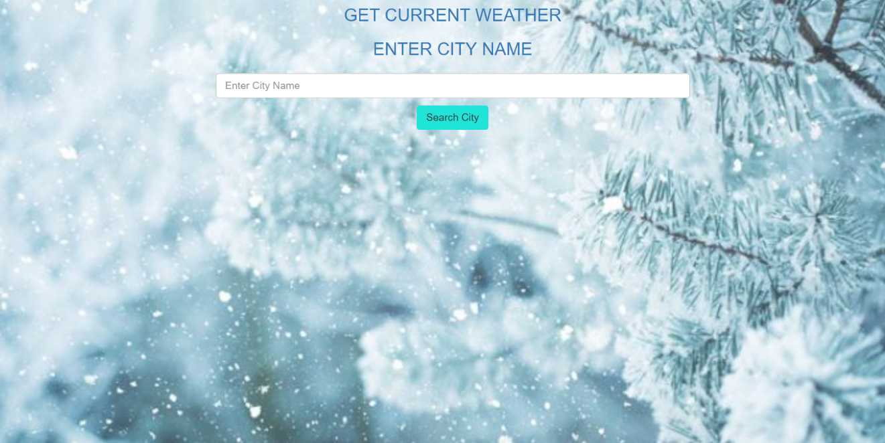

After the user enter the name of the city of the weather app forecast ,the ajax request will be sent to open weather map along with the name of city. Weather data will be fetched in the form of XML file which will be parsed to show the details in a following way.

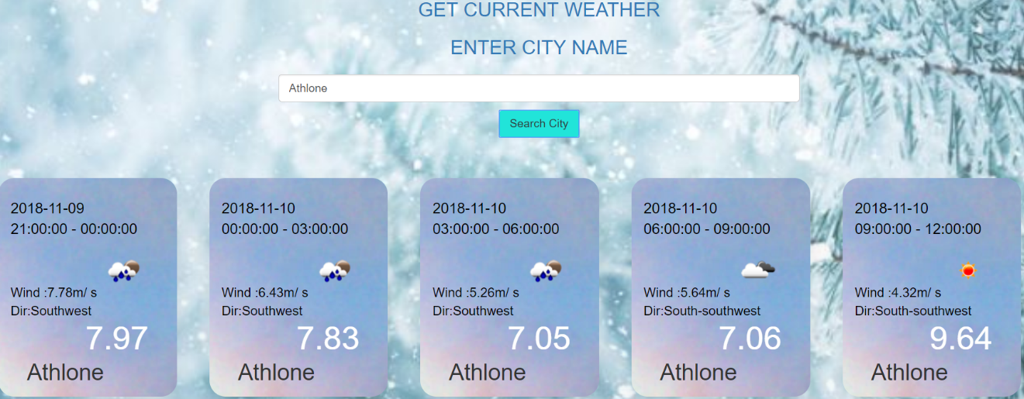

In the above picture is the forecast for Athlone. Separate weather cards will be created for every detail in the interval of three hours .The Weather Card will contain details such as

* Current Date
* Time Interval for the data
* Wind Speed
* Wind Direction
* Current Temperature
* Climate condition through a picture.

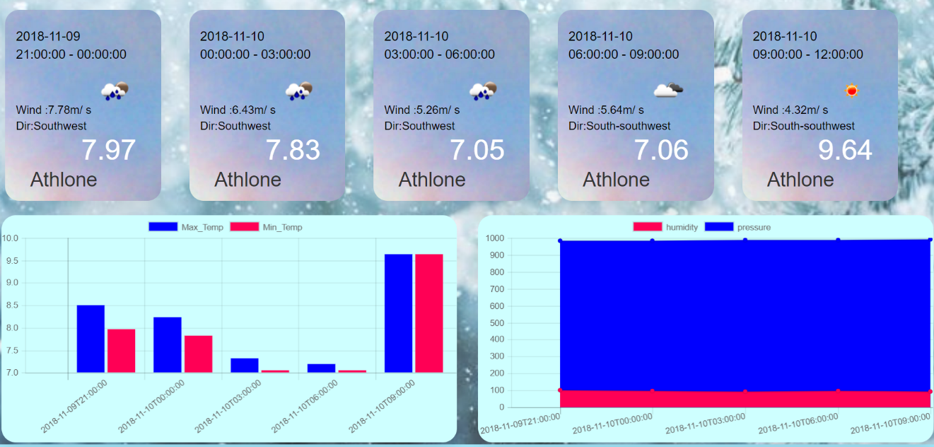

The Graphs are Also Created with the help of charts.js library .Bar graph to show the minimum and the maximum temperature of the five intervals and the line graph to show the variation in humidity and pressure .

# **Ajax**

The function within my JavaScript code which initiates the AJAX call . The HttpObject function will be called which will return the HTTPObject and setting it equal to a variable name “request”. This basically sets up the communication between the client and the server. The parse response method will get the response from server (XML file) and store it in variable data.

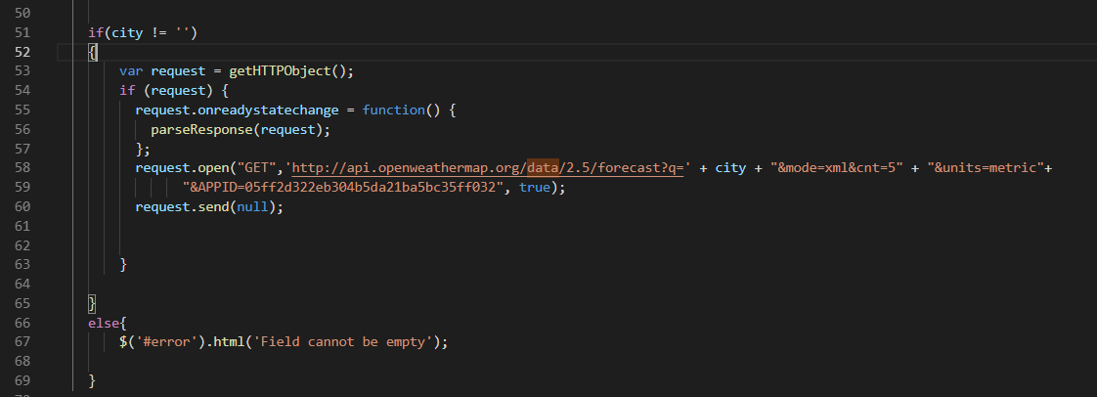

# 

# **DOM**

I used the DOM model to display the XML data that was requested in the AJAX call.As you can see in my code the “parseResponse()” function basically parses the received XML data using the DOM concept.The function basically says that if the “readyState” & “request.status” are equal to a specific value then we do the following:

Create a variable named “data” and make it equal to the XML request response. This stores the XML in a variable for use later.

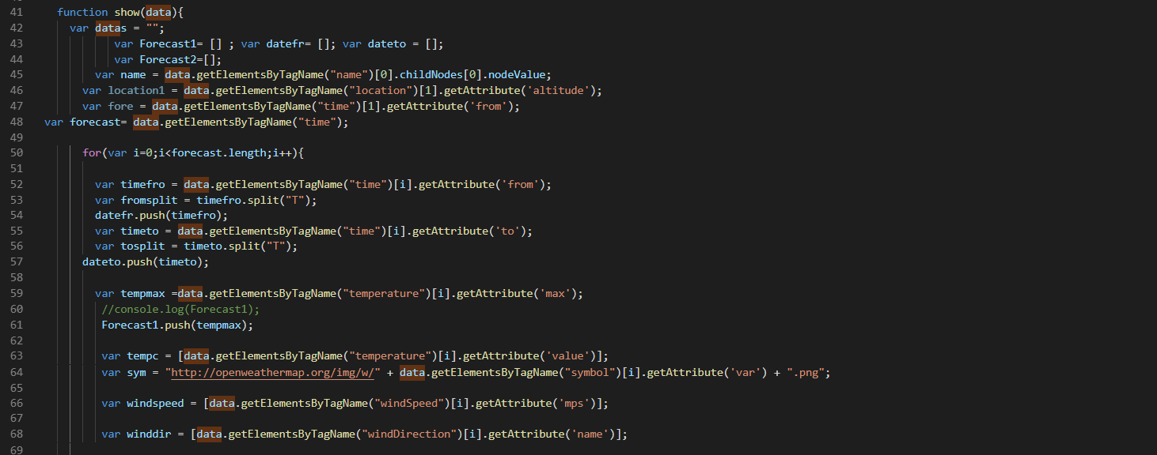

The above code explained:

* The above code is getting the city name that is located in the tag name “name” which was part of the information that we got from the XML data .
* All the arrays forecast1,2,3,4 are initialized to store the weather data .
* Variable forecast will store all the data from XMl with tagname “time”.
* We will iterate through all the time tags to get weather data for every three hour interval .
* Timefro will get the attribute from tagname time ,timeto will get the attribute to from tagname “time” and so on.

Below is the code I used to create the weather cards in my JavaScript and display it on my HTML.

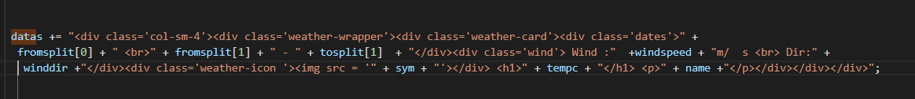

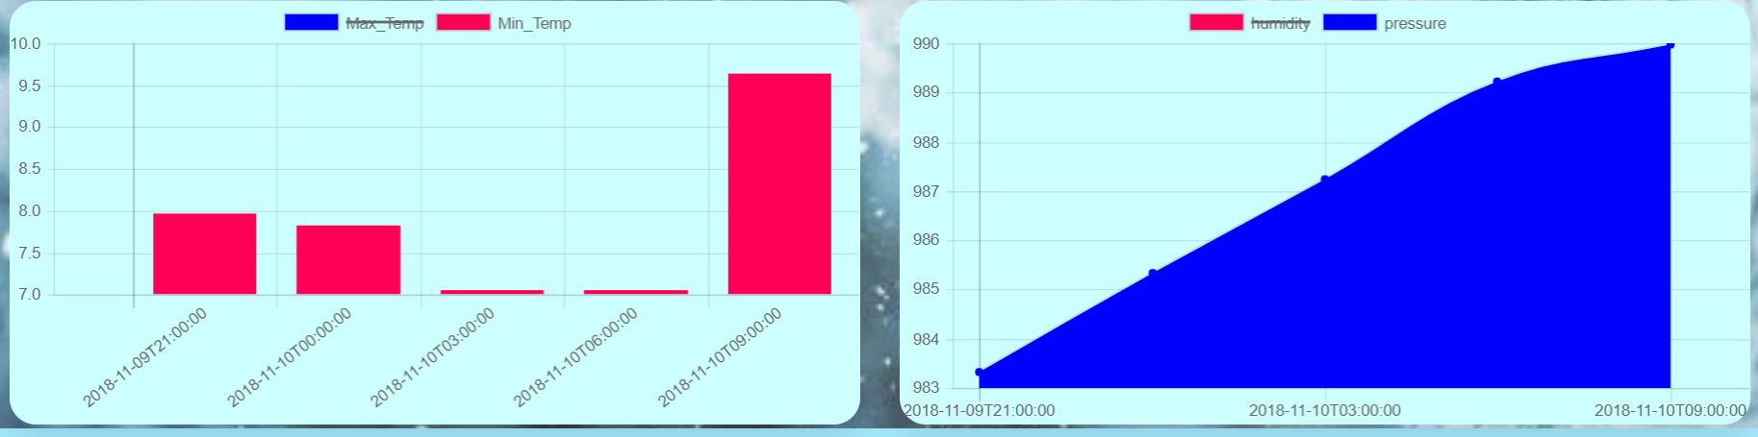

The Above Graphs Represent the variation in temperature and pressure and humidity.

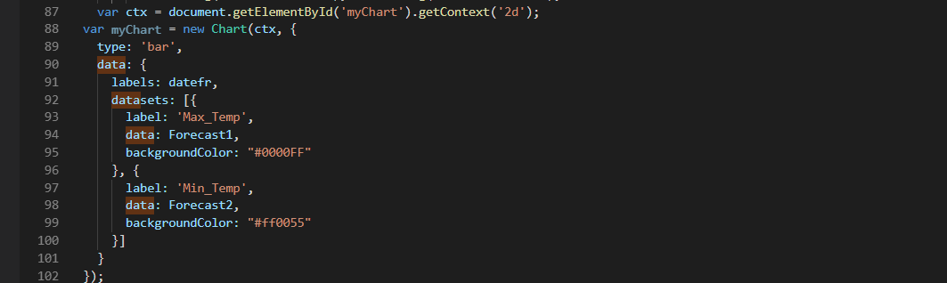

The Above Code Explains the creation of graphs

Variable ctx will locate the canvas with id”myChart” then we will use ctx to create a bar graph and provide the labels as datefr which is the array which contains all the time intervals.

The array Forcast1,2 will contain the maximum and minimum temperature over those intervals.

# **CSS**

I implemented just some basic CSS to display that I have learned from the labs. I implemented styling such as image background for the body background. I used Bootstrap library to beautify the look and feel of the website I used it to create and display weather cards in attractive manner.

Below is the code I used for styling of weather cards.

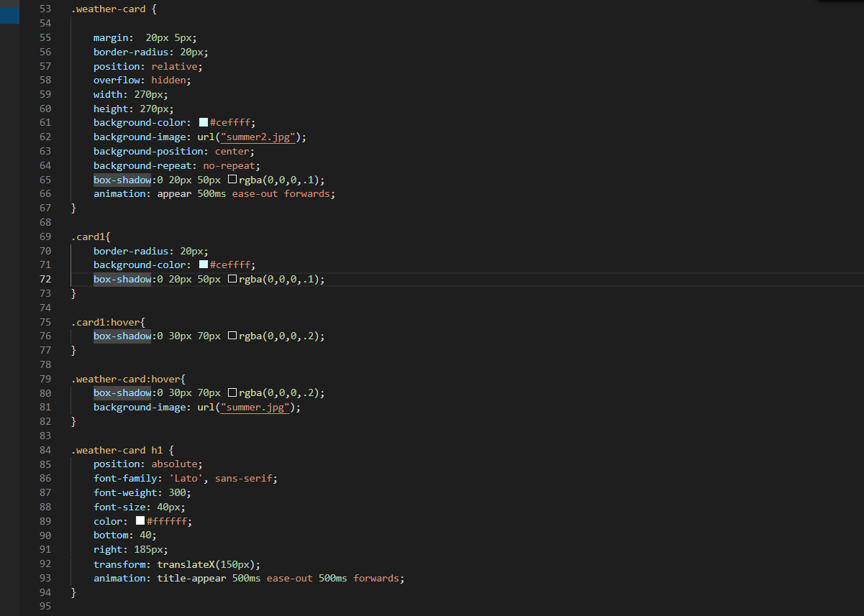

# **CONCLUSION**

This assignment was a good learning curve that showed me the implementation of AJAX and DOM scripting as well as using online API’s in a live scenario . It helped me to further increase my knowledge of HTML, CSS and JavaScript. It was a good experience to explore some API and Libraries and I also got to learn few tricks of using bootstrap and implementing it for a better view and feel of web page.